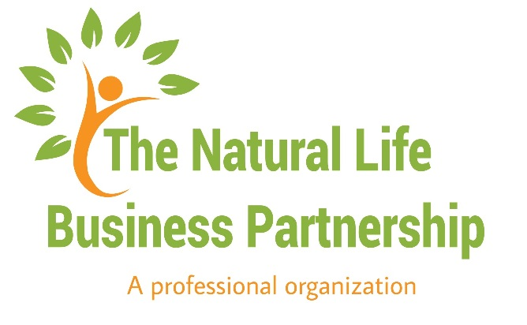
________________________________________________________________________________________________

90-Day Goal Challenge
________________________________________________________________________________________________

The next 90 days are the most critical when beginning a new habit or simply reaching a goal.

Take some time to focus on your most important goals. Think about what goals are possible within the next 90 days. If a goal seems overwhelming, break it up into smaller chunks to conquer large obstacles.

Consider both professional and personal goals and write down the goals that you feel comfortable discussing. Take a look at the example below:

Start | End | Goal | Completed
Oct 1 | Oct | Meditate at least 20 minutes each morning. | Yes
Benefit: Relieves stress from hectic schedule and allows time to re-focus on work. I will continue to do so beyond my end date.

Now, to repeat the importance of goal setting, take some time to think of the benefits of these goals. Imagine yourself completing each one and write down the positive impact of reaching that victory.

On our next call, we will discuss these benefits and goals to you help create an official plan of action and get you set for reaching your goal by the end of the year.

Continue to the next page to begin the activity.

Start | End | Goal | Completed
Benefit:

Benefit:

Benefit:

Benefit:

Benefit:

Let us know how you are doing reaching your goals by posting each day in our Facebook Group with the hashtag #90daystoGoal. Before you post your progress please make a positive comment on someone else’s post. You got this!!!!

